**Project Design Phase-II**

**Data Flow Diagram & User Stories**

|  |  |
| --- | --- |
| Date | 26-05-2025 |
| Team ID | LTVIP2025TMID54893 |
| Project Name | DocSpot |
| Maximum Marks | 4 Marks |

**Data Flow Diagrams:**

A **Data Flow Diagram (DFD)** illustrates how data moves within the Freelance Finder platform. It captures how users (freelancers and clients) interact with the system, how information flows between different components, and where the data is stored.

**DFD Level 0**: The user submits a complaint which is stored in the database. Admins review and assign the complaint to a suitable agent. Agents update the status as they process the complaint. Users can log in to check complaint status and receive updates.

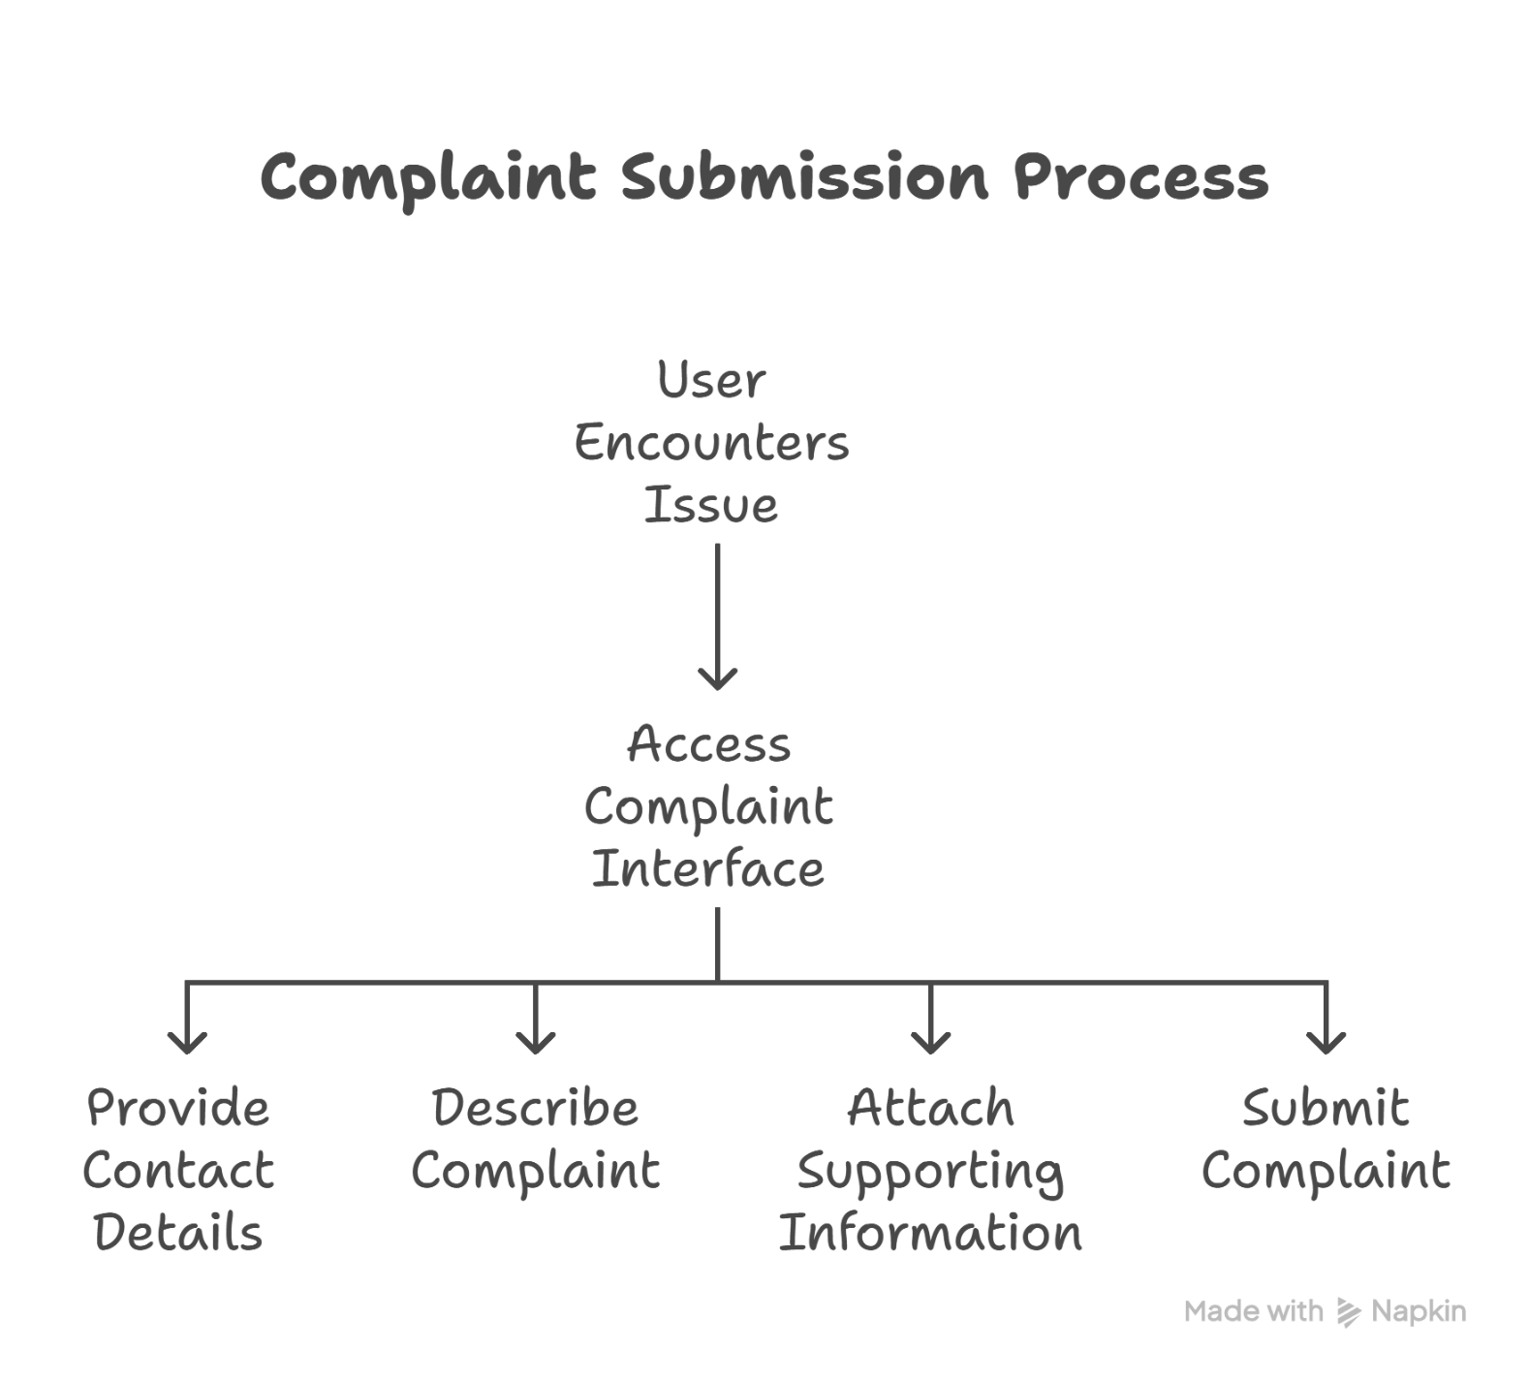

**User Stories**

**User Story Table – DocSpot**

|  |  |  |  |  |  |
| --- | --- | --- | --- | --- | --- |
| **User Type** | **Functional Requirement (Epic)** | **User Story / Task** | **Acceptance Criteria** | **Priority** | **Release** |
| |  | | --- | | **User** |  |  | | --- | |  | | |  | | --- | | Complaint Submission | | As a user, I can submit a complaint with details. | Complaint is stored and visible in user dashboard. | High | Sprint-1 |
| **User** | Status Tracking | As a user, I can view the current status of my complaint. | Status updates reflect in real-time.   |  | | --- | |  | | Medium | Sprint-2 |
| Agent   |  | | --- | |  | | |  | | --- | | Complaint Handling |  |  | | --- | |  | | |  |  | | --- | --- | | As an agent, I can view and update assigned complaints.   |  | | --- | |  | | | |  | | --- | | Changes are logged and visible to users. |  |  | | --- | |  | | High | Sprint-1 |
| **Admin** | Complaint Assignment | As an admin, I can assign complaints to agents. | Assignment reflects on agent dashboard. | Medium | Sprint-2 |
| **Admin** | User Management | As an admin, I can manage users and their | Changes take effect immediately. | High | Sprint-2 |
| **User** | Authentication | As a user, I can register and log in securely. | Login session maintained with JWT.. | High | Sprint-2 |